TEAMSTERS LOCAL UNION NO. 19

Airline, Aerospace and Allied Employees – Arkansas, Louisiana, Oklahoma and Texas
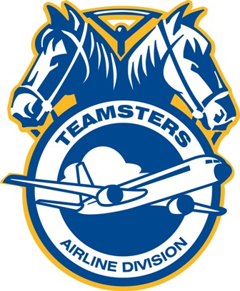
Houston
5939 Bender Road
Humble, TX 77396
Phone: (713) 672-8155
Fax: (713) 672-9622

Robert Rasch Dominic Fierro
President/Business Manager Secretary-Treasurer

NORTHROP-GRUMMAN

TENTATIVE AGREEMENT #3

IS RATIFIED

The Northrop-Grumman Tentative Agreement #3 Vote, was held on Tuesday August 10, 2010 at the Landmark Hotel in Leesville, La. There were three meetings scheduled for questions and answers after each one, members cast their votes. The ballots were tallied at 7:00pm.

OF THE BALLOTS CAST:

86% YES

14% NO

Local 19 will notify the Company as soon as possible the names of the Chief Steward and Shop Stewards as they are appointed. Also we will start the process of setting up bulletin boards. As information comes available it will be posted on the website: www.TeamstersLocal19.org.

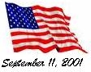Fraternally,
Mike Cline
Business Agent/Trustee

